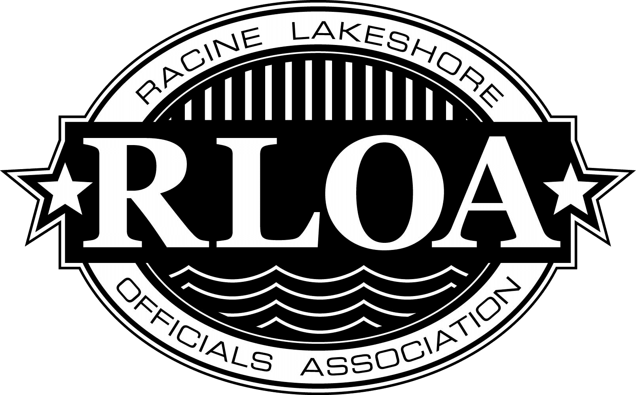
RLOA 2nd Umpire Baseball Clinic

This is an invitation to all that would like to learn more about umpiring. The Racine Lakeshore Officials Association Inaugural Baseball Umpire Clinic will be held on Sunday March 16th from 9AM-5PM at Tremper High School located at 8560-26th Avenue Kenosha, WI 53142 inside the gym area. This clinic is open to any level umpire new to experienced.
The Baseball clinic has been approved by the WIAA and you will receive credit for attending and leveled up. If you are not licensed with the WIAA or not working high school baseball but want to work spring and summer tournaments this is an opportunity to gain knowledge about the kraft of Umpiring Baseball and info on how to become a WIAA baseball umpire. Assignors will be in attendance during the clinic.
The clinic will consist of classroom training, on field mechanics, Plate mechanics (videotaped feedback) etc. If you enjoy working baseball and would like some basic training on how to work, better your craft and be seen by assignors to be evaluated this is the camp for you.
Registration will be $75.00 for Adults and Students $25.00. Lunch will be provided. Please fill out the Registration Form by the deadline to attend the camp. Please arrive 8-8:45 AM to check in. Camp will start at 9 AM.
Plan on participating most of the day, bring your plate gear with you and if you do not have any the camp can provide equipment to be used for the training.
If you have any questions, please contact:
Scott Trottier at 262-945-1600 or by email at: trotts1616@gmail.com.

I am looking forward to seeing all of you for this great opportunity.

